***Here are the details of services and events happening in the Benefice of Buckrose Carrs this coming month:***

|  |  |  |  |  |
| --- | --- | --- | --- | --- |
| 2nd February | Candlemas | 9.00am  St Andrew’s Rillington  11.00am  St John’s Yedingham | Common Worship Communion  BCP Communion | Malachi 3:1-5  Luke 2:22-40 |
| 9th February | 4th Sunday before Lent | 10.15am  All Saints’ Thorpe Bassett | BCP Communion | Isaiah 6:1-8 [9-end]  Luke 5:1-11 |
| 16th February | 3rd Sunday before Lent | 10.15am  All Saints’ West Heslerton | Common Worship Communion | Jeremiah 17:5-10  Luke 6:17-26 |
| 23rd February | 2nd Sunday before Lent | 10.15am  Sherburn  11 St John’s, Yedingham  4pm  Church Rooms, Rillington | Common Worship Communion  Word Service  Café Church | Genesis 2:4b-9, 15 – end  Luke 8:22-25 |

If you have any queries, please contact your churchwarden:

|  |  |
| --- | --- |
| Rillington - Rodney Wood - 01944 758651 | Thorpe Bassett - David Harrison - 01944 768548 |
| Scampston – Vacant | West Heslerton – Roger Sugden - 01944 728271 |
| Sherburn – Richard Murray – 0783 320 6802 | Yedingham - Rob Tindall - 01944 728366 |

If you'd rather worship from home, you can also find a weekly worship service on the Church of England website at https://www.churchofengland.org/news-and-media/church-online/weekly-online-services. Services are pre-recorded and available to watch at any time.

**Also happening in our Benefice.......**

**Rillington Community Café**

The Community Café takes place each Tuesday morning from 9.45 to 11.30 in Rillington Village Hall.

**West Heslerton Community Café**

Held on the first Monday of every month at the Village Hall 9.30 to 11.30 am



**Little Fishes Parent and Toddler group 9.00 - 10:30**

Every Monday in ‘Term time’ Rillington Church Rooms

*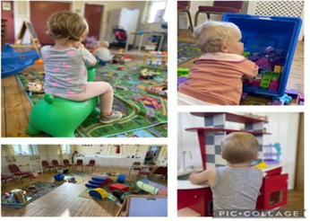Just a £1.50 Voluntary Donation is required*



